**Dear Families,**

The Coronavirus (COVID19) has dominated the news this week and many discussions have been taking place at Government level on the best way to tackle this crisis. As you are probably aware, the Government has moved into the delay phase and has announced that no widespread school closures are imminent in England. Please rest assured that REAch2, our Academy Trust has robust plans in place should the advice change and a school closure need to take place. An email will be sent out today with a letter from Sir Steve our CEO, containing further information. In the event of a closure, it will be communicated to you via text and posted out on Twitter and on our website. Please keep sending your child to school unless they are unwell with a persistent cough or high temperature – this also comes as the latest guidance from the Government in the attempt to delay the spread. They should self-isolate for 7 days. If anyone in your family home has been in contact with anyone with COVID19 or suspected of having it, the advice is for that person to self-isolate. Please do let us know if this is the case. We continue to ensure the children are regularly washing their hands which is still the best way of avoiding the spread of this virus. Please do all you can to support this at home. If you have any questions do not hesitate to speak to myself or Mrs Dennis.

**Year 1 Reading under the Stars – 11B411 Adventure:** What a brilliant event this was last week! The children were so excited to come back in their pyjamas and slippers and took part in a variety of activities in the dimly lit hall with star projector before taking their hot chocolates outside to listen to a story when it got dark. Everyone had a great time and the hour really did fly by! A massive thank you to Miss Lester and Mr Parker for organising such a fab 11B411 adventure and the children got to earn another pin badge for their lanyard – this time a little gold star for Reading Under the Stars!

**Science Week:** We’ve had a very scientific week to celebrate this which cumulated with a great day yesterday when William’s Dad came in and did some fantastic science activities with each of our classes which included making circuits and conducting electricity! The children thoroughly enjoyed themselves and we certainly saw some budding Scientists!

**Sports Relief:** As the newsletter goes to print in the morning, this has not yet happened but I am sure it is going to be lot of fun as we march on round the field 4 times. For those more energetic ones, they will run some of it. I think we may have some tired legs by the end of it! Thank you in advance for any sponsorships you have been able to collect on behalf of this great cause. If you’ve not been able to hand the form and money in today, please send in no later than FRIDAY 20TH MARCH so that Mrs Dennis can send the money off.

**Mothers’ Day Meal:** I have taken advice from REAch2 regarding this event and as we are such a small school and there will be around 90 people at it including the children, it will still go ahead at this moment in time. We are super excited to welcome all our Mums in to share this special meal with us! Look out on Twitter for pictures of the event!

**NSPCC PANTS campaign:** As mentioned last week, we will be completing the PANTS campaign with the children next week. Hopefully you have had time to familiarise yourself with the materials and asked any questions if you’ve had any. Don’t forget to check the website out too. <https://www.nspcc.org.uk/keeping-children-safe/support-for-parents/underwear-rule/>

**Spring Disco – 30th March 5-6:30pm:** Tickets will be on sale from Monday afterschool under the canopy by the Reception Class entrance. The cost is £3.

**Staffing news:** Mrs Morgan, our wonderful Year One Teaching Assistant and Breakfast Club leader will be leaving us at Easter to take up an exciting full time promotion, nearer to home in Tamworth as a Higher Level Teaching Assistant. Mrs Morgan is very sad about leaving us and if we had such a position available at this school, she certainly would have wanted to stay. Watch this space, Mrs Morgan!! We are currently advertising for Mrs Morgan’s replacement and I will keep you informed as to when we have made an appointment.

In other staffing news, we had an amazing response with over 30 applications for our next year’s teacher as the school continues to grow and we will be interviewing next Friday! Again, I will announce in the newsletter who we have appointed.

**Harrier Award:** This week Miss Jack and Mrs Carlile have chosen Ethan due to his engagement in our Science Week, he particularly loved making and breaking a circuit when William’s Dad was here. Well done Ethan! This week Miss Lester and Mrs Morgan have chosen Nova for brilliant Art work. She experimented with colours and tried new techniques and had some great results! Well done Nova!

Have a great weekend, with very best wishes,

Mrs Hopkins & The Henhurst Ridge Primary Academy Family

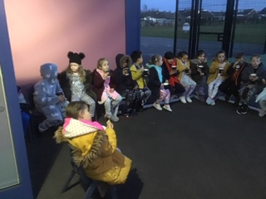 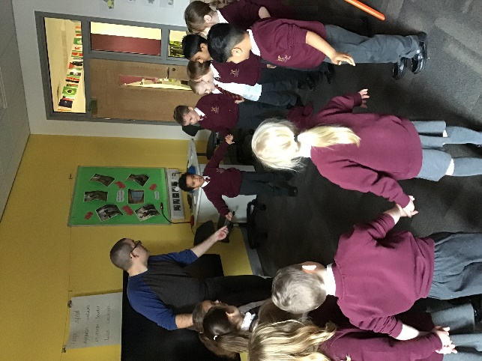

Year One Reading Under the Stars!! Making circuits in Science!

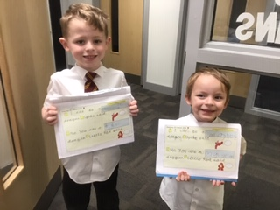 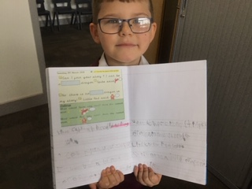

George & Lukas with incredible writing! Even more great writing – from Leo this time!