Dear Families,
Can you believe it’s Friday again? The Little Harriers have been so busy this week. In their Letters and Sounds sessions they have explored different ways of using their bodies to make noise and develop their awareness of sounds and rhythms. They have put together a fabulous story map to support a retelling of the story ‘Dear Zoo’ and have had lots of fun exploring different 2D shapes in order to make patterns and pictures. Busy indeed!
Thank you for the fabulous contributions to Tapestry that we have received again this week. We have been on a trip to the chocolate factory, seen some of your pets and had a look at some of your shape activities at home. Wonderful!
Just a couple of important notices to pass on. Please could you ensure that your child/ren wait with you at the gate in the morning and are not able to run or ride down to the end of the car park area, which is in constant use. We obviously want to keep all of our Little Harriers safe and sound so if you could please keep them with you, the gate will open at 8.45am ready to welcome you all in safely.
This week, we have also had a huge number of toys being brought in from home. As mentioned in a previous newsletter, this can cause issues within nursery as all of the children understandably want to play with them and do not realise that they are not nursery items for everyone to access. Children bringing items in also have to be supported to put the toys away so that they can get on with the planned activities in the setting and we have had a few issues this week at the end of the session when these toys have been mislaid. We do understand that the children often have new things that are special to them that they are keen to show everyone, so can we please ask that such items now only come in on a Friday (no more than one item each) so we can share them in a brief ‘Show and Tell’ chat at the end of the session. Thank you for your co-operation with this.
Birdie time! He has been watching from his roost as always and has decided that he would love to go and visit Harris this weekend. Our current British value is ‘Tolerance’ and Harris has shown this all week as he has reminded others about lining up nicely in particular before going outside to play.

Have a great weekend!
Dates for your diary:
Wednesday 18th March- 8.45-10.00am- Mum’s Stay and Play session
Friday 3rd April – Easter Bonnet Parade- to be held in the hall at 9.00am.
Wishing you a great weekend,

Mrs Blackshaw and Mrs Buckley 😊
Home learning- keep looking out for shapes and patterns in your home and beyond!
Thank you!

Spotting a circle on our shape walk.

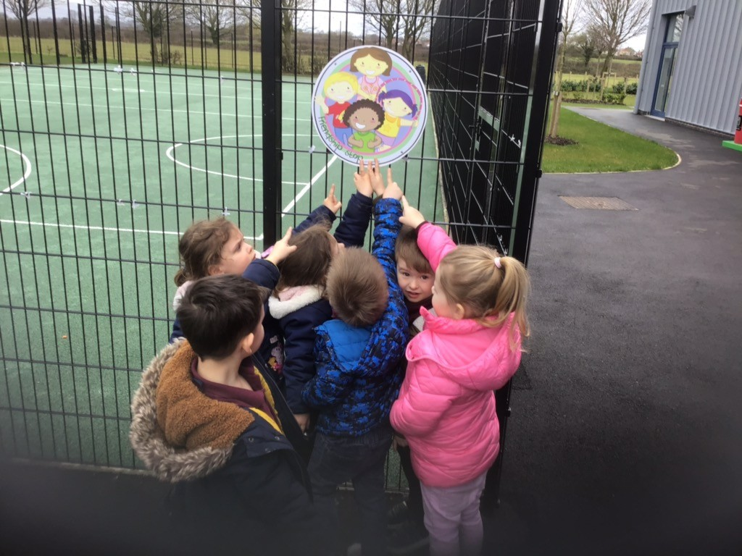
UPDATE ON THE CORONAVIRUS:
The Coronavirus (COVID19) has dominated the news this week and many discussions have been taking place at Government level on the best way to tackle this crisis. As you are probably aware, the Government has moved into the delay phase and has announced that no widespread school closures are imminent in England. Please rest assured that REAch2, our Academy Trust has robust plans in place should the advice change and a school closure need to take place. In the event that this becomes necessary, it will be communicated to you via text and posted out on Twitter and on our website. Please keep sending your child to school unless they are unwell with a persistent cough or high temperature – this also comes as the latest guidance from the Government in the attempt to delay the spread. They should self-isolate for 7 days. If anyone in your family home has been in contact with anyone with COVID19 or suspected of having it, the advice is for that person to self-isolate. Please do let us know if this is the case. We continue to ensure the children are regularly washing their hands which is still the best way of avoiding the spread of this virus. Please do all you can to support this at home. If you have any questions do not hesitate to speak to myself or Mrs Dennis.

